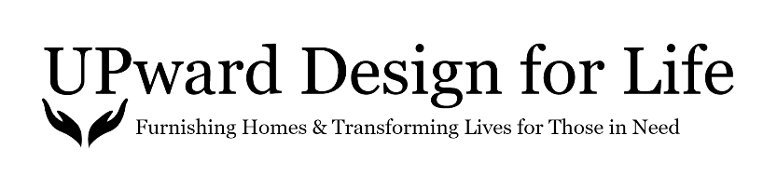

Team Building Program Agreement

Thank you for your interest to build employee trust and camaraderie while serving our community, through the UPward Design for Life Team Building program! Together, we will continue of mission of restoring hope by transforming empty spaces into homes, for individuals and families in need.

When serving households through the UDFL Team Building Program, participants must agree to the following:

- Protect the privacy of our clients at all times by not taking photos of individuals or families, sharing their home address with others outside of the project, and avoid engaging in extension conversations with the client or asking personal questions.
- Never be alone in a space, with a client or child, at any time.
- Work as a team, to lift heavy items. In order to avoid injuries, no one should lift heavy items alone.
- All participants must dress comfortably. Please avoid sandals or any footwear that does not cover the feet completely.
- Sign the UDFL Waiver of Liability Agreement (will be provided in advance) prior to starting the furniture installation project.
- Wear a mask, should it be the request of the client, while in their home.

By signing this agreement, you confirm that you have read and agree to the above program requirements.

Company Name: ______________________________________________________________

Company Address: ____________________________________________________________

Contact Name: ________________________________________________________________

Phone Number: ____________________ Email: _________________________________

Program Fee: $3,000

