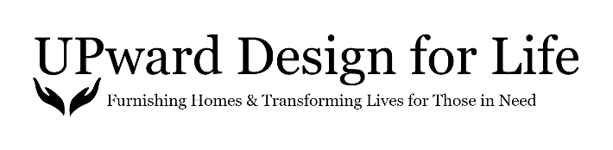
2019 Year-End Report

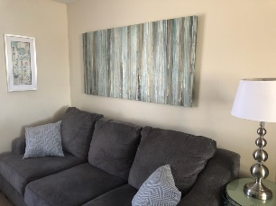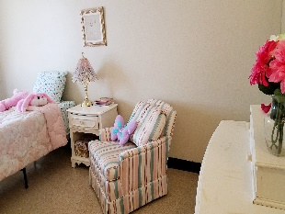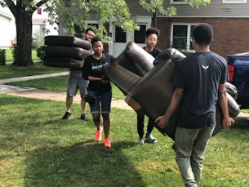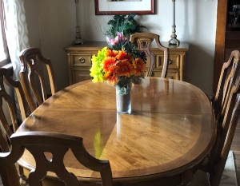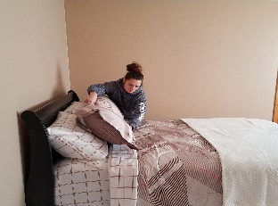

We are pleased to finish out our second year of operation! We are grateful for the support we have received this year!

Here is a re-cap of achievements:
-Welcomed three new Board members to our team, Teresa Vincent-Nova Healthcare Administrators; Nancy Redeye-Flynn Battaglia Architects PC; and Cheri Alvarez-Compeer Buffalo.
-Gained Oishei Healthy Kids, BestSelf, Native American Community Services, YWCA of Niagara County, Compeer Buffalo, International Institute of Buffalo and Baker Victory Services as new Non-Profit Partner Agencies.
-Served 14 individuals/families in need bringing our total of families served to 30 since starting operations in January of 2018.
-Received financial contributions, from the general public, totaling $4,615.00.
-Received corporate financial contributions totaling $1,000.00.
-Received gifts-in-kind totaling $1,552.00
-Received roughly over $40,000 in new or gently used furniture and accessories.
-Dionne Williamson, President/Founder, was the recipient of the William B. Hoyt Advocacy Award from Child & Family Services.
-The UDFL Board has created our 2020-2022 Strategic Plan.

Areas to improve:
-Fundraising initiatives. With our 2020 Strategic Plan now created, we have attainable quarterly goals set. Creating an Adancement/Fundraising Committee being part of our 2020 Q1 goal has already been accomplished. We now have a committee of eight.
-Researching grant opportunities. We currently have a list of grants we will apply for in 2020 and the timeline, for submission of our applications, for each.
-Demonstrating value-client outcomes. Tracking, differentiating and transmitting value UDFL produces. In 2020, we will begin providing the clients we serve, with questionnaires, after services are rendered so they can share their views of our services. We will also look to our non-profit partner agencies for insight regarding the services we are providing to their clients.

The 2020 year ahead:
The UDFL President and Board of Directors are energized about the 2020 year ahead. We are moving forward with a strategy of success that we believe is attainable based on our current size and available resources.
As always your continued support of our efforts are greatly needed. Please consider making a financial contribution today by clicking on the Take Action tab of our website: www.upwarddesignforlife.org.
Thank you!
UPward Design for Life Board of Directors

